- How LangFuse is used in the Python Code
  - Project Setup
When you first configure your organization in langfuse control plane, you have to create API Keys as below (LANGFUSE_SECRET_KEY, LANGFUSE_PUBLIC_KEY, LANGFUSE_BASE_URL).
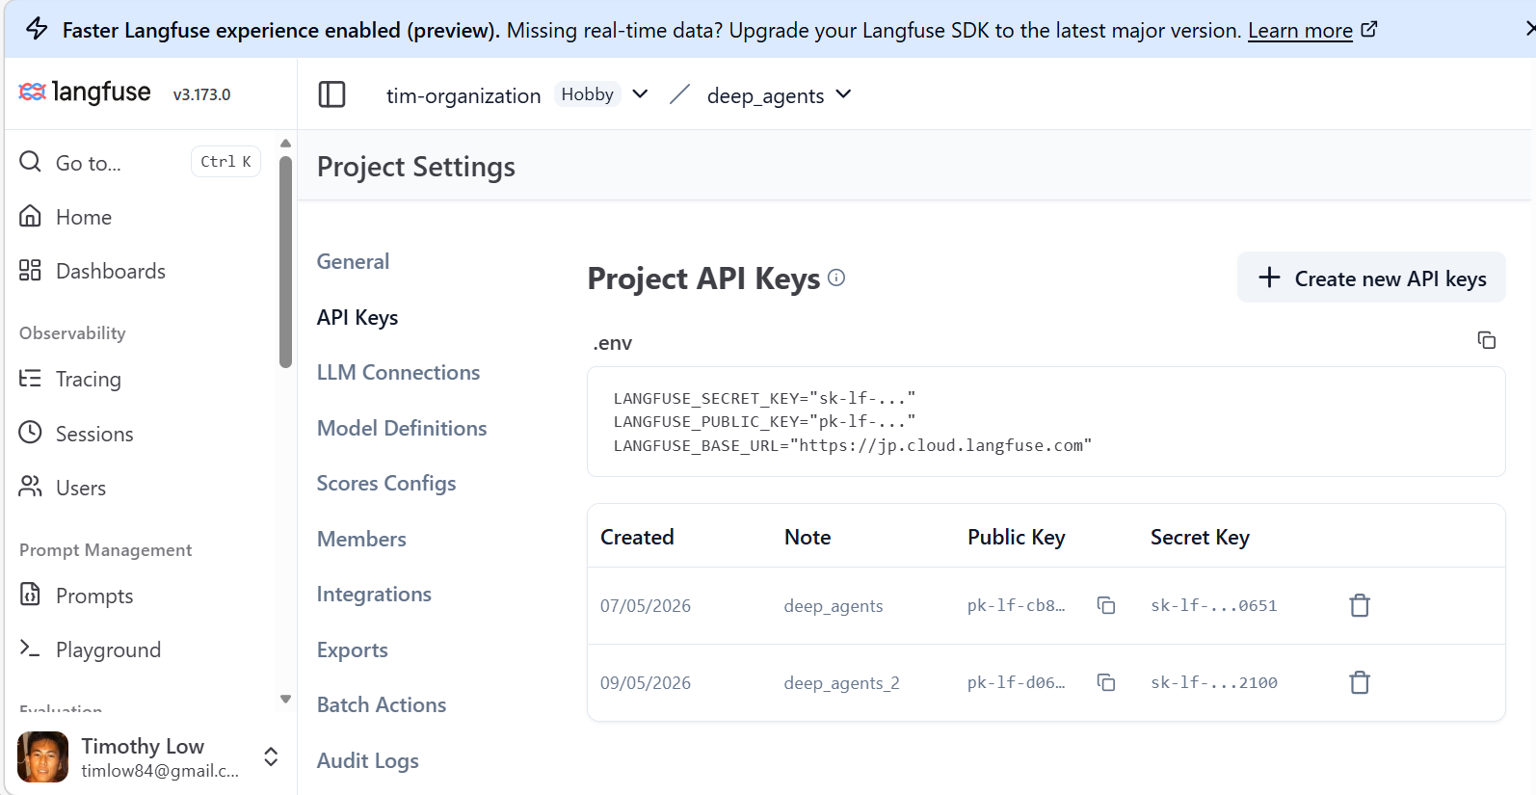
In your python project, declare the above API Keys for LangFuse in your .env file which will automatically be picked up by the LangFuse runtime.
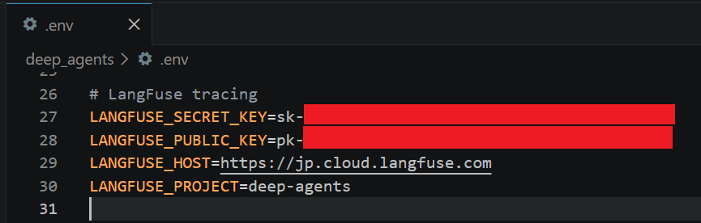
Tip: You can set LANGFUSE_TRACING_ENVIRONMENT=development in your .env file above so that the LangFuse traces will be tagged under “Environment”
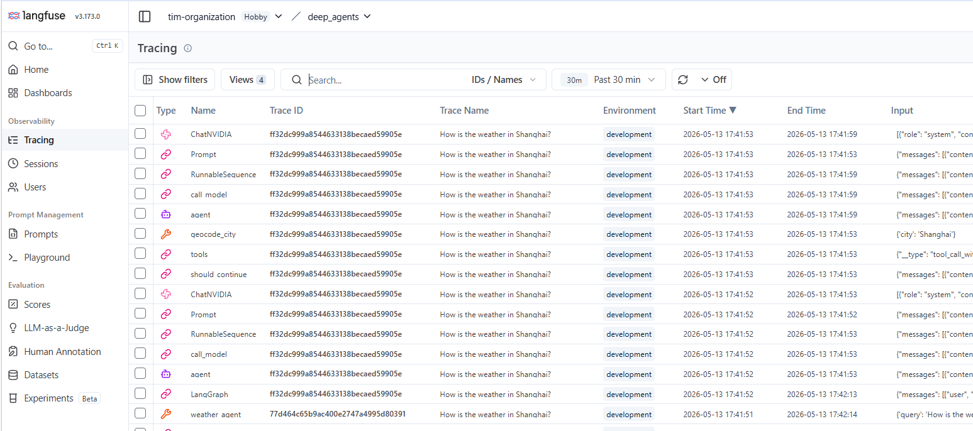

  - Shared pattern in both agents
GitHub Reference: deep_agents/agents/a2a at master · timlow84/deep_agents
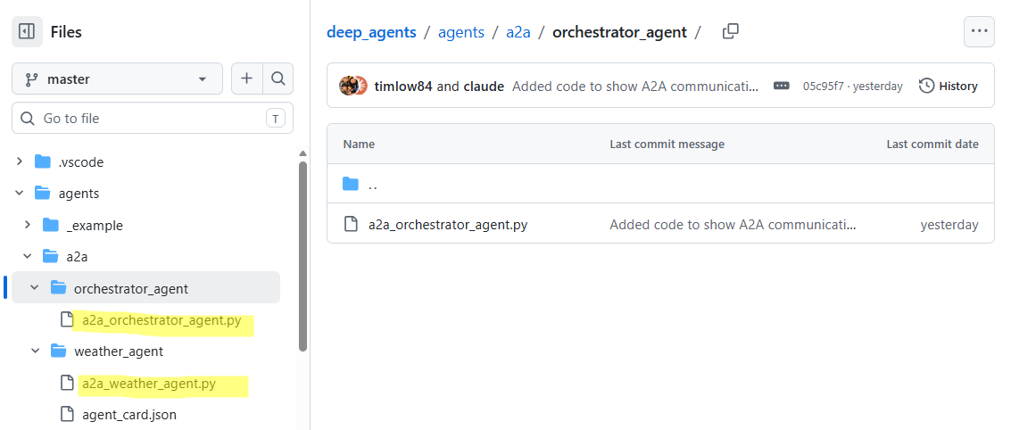
Both agents communicating through a2a use the same two LangFuse primitives:
Import | Purpose
CallbackHandler from langfuse.langchain | LangChain callback that auto-instruments every LLM call, tool call, and chain step
propagate_attributes from langfuse | Context manager that tags all spans with a session_id and trace_name

    - Orchestrator agent (a2a_orchestrator_agent.py:148-156)
langfuse_cb = CallbackHandler()
with propagate_attributes(session_id=str(uuid.uuid4()), trace_name=query[:120]):
result = await graph.ainvoke(
{"messages": [HumanMessage(content=query)]},
config={"callbacks": [langfuse_cb]},
)
_langfuse_module.get_client().flush()
- A new CallbackHandler is created per query (so each conversation turn is a separate trace)
- session_id is a fresh uuid4() — groups spans into one session in LangFuse
- trace_name is the first 120 chars of the user's query — this is the "How is the weather in Singapore?" you see in the Trace Name column
- The callback is passed into graph.ainvoke via config={"callbacks": [...]} so LangChain propagates it to every node
- .flush() in finally ensures all buffered spans are sent before the loop continues

    - Weather agent (a2a_weather_agent.py:191-204)
langfuse_cb = CallbackHandler()
session_id = context.task_id or str(uuid.uuid4())
with propagate_attributes(session_id=session_id, trace_name=user_text[:120]):
result = await self._graph.ainvoke(
{"messages": [("user", user_text)]},
config={"callbacks": [langfuse_cb]},
)
_langfuse_module.get_client().flush()
- Same pattern, but session_id reuses the A2A task ID (context.task_id) so all spans for one A2A request stay grouped
- This runs inside WeatherAgentExecutor.execute(), called per incoming A2A JSON-RPC request from the orchestrator

- Observability in LangFuse Dashboard
  - What you see in the LangFuse screenshot
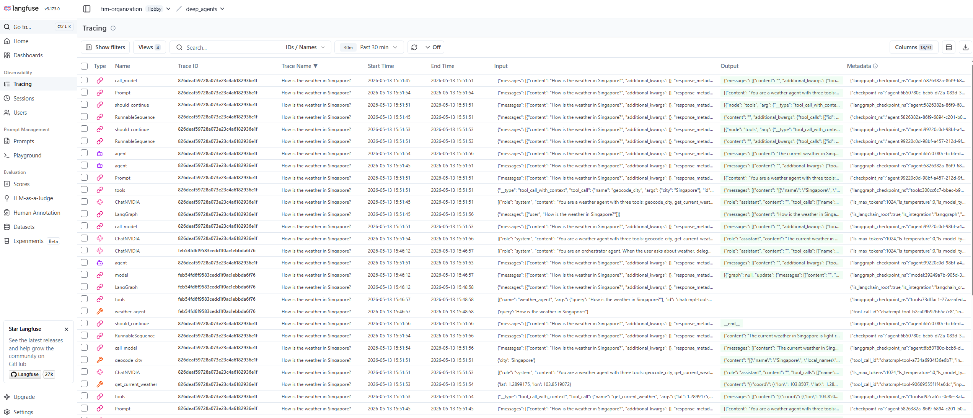
The two Trace ID values in the screenshot reveal the two separate traces:
Trace ID | Agent | What it captures
826deaf59728... | Weather agent | LangGraph → ChatNVIDIA/ChatAnthropic → tools → geocode_city → get_current_weather
feb54fd6f958... | Orchestrator agent | LangGraph → model → tools → weather_agent (the A2A call)

The CallbackHandler hooks into LangChain's event system and automatically captures:
- LangGraph — the outermost graph span (start/end times for the full invocation)
- agent — the ReAct agent loop node
- Prompt / call_model — each LLM call with full input/output
- tools / geocode_city / get_current_weather — each tool execution
- should_continue / RunnableSequence — internal routing nodes
The propagate_attributes context manager ensures the session_id and trace_name (the user's query text) are attached to every span created within that with block, which is why the Trace Name column shows "How is the weather in Singapore?" for all rows across both agents.

